 [Translated from French to English - www.onlinedoctranslator.com](https://www.onlinedoctranslator.com/en/?utm_source=onlinedoctranslator&utm_medium=docx&utm_campaign=attribution)

1. **Distribution of chemotherapy centers in West Africa**

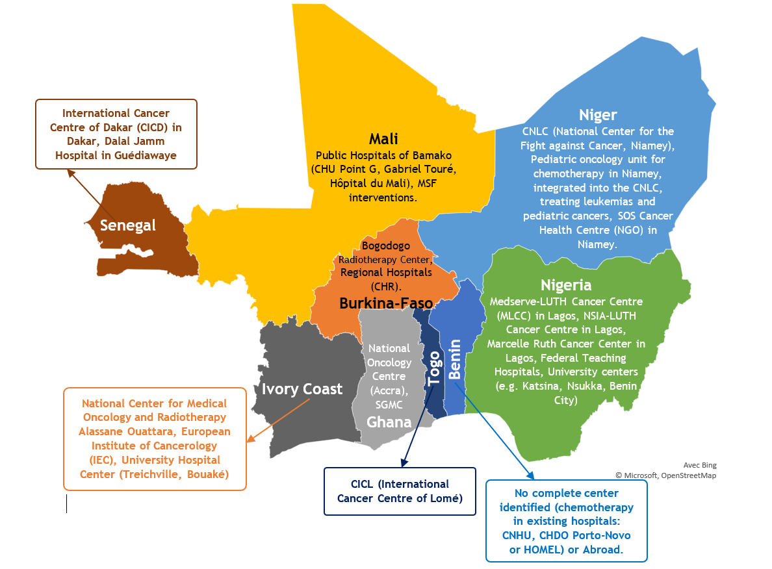

Figure: Distribution of chemotherapy centers in West Africa

1. **Distribution of radiotherapy centers in West Africa**

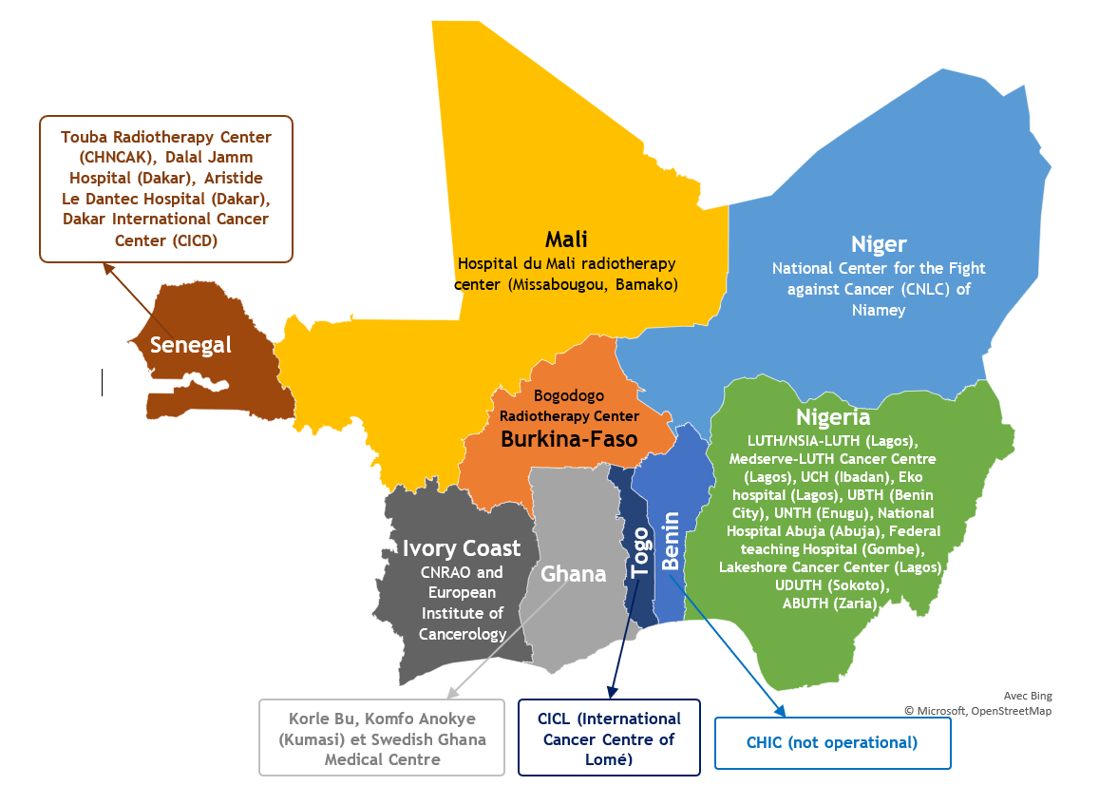

Figure: Distribution of chemotherapy centers in West Africa

1. **Resources for neuro-oncologists in the ECOWAS region**

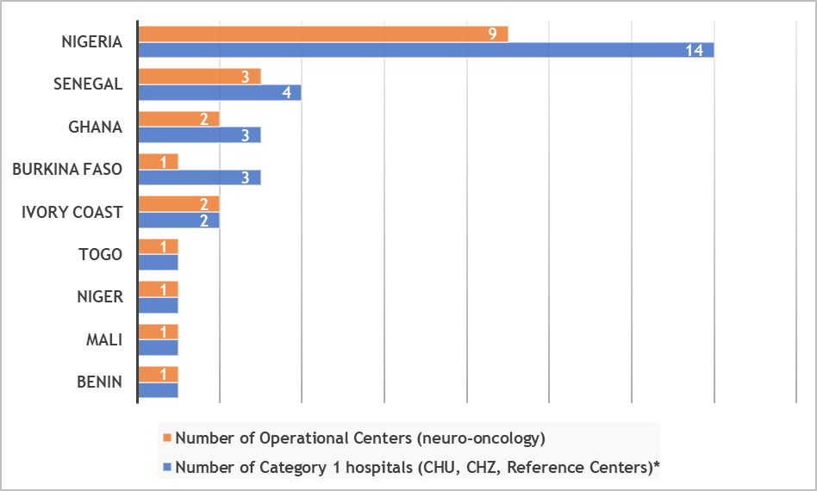

**Figure 1:**Distribution of neuro-oncology centers in ECOWAS countries

1. **Spectral distribution of specialist staff by discipline in the ECOWAS region**

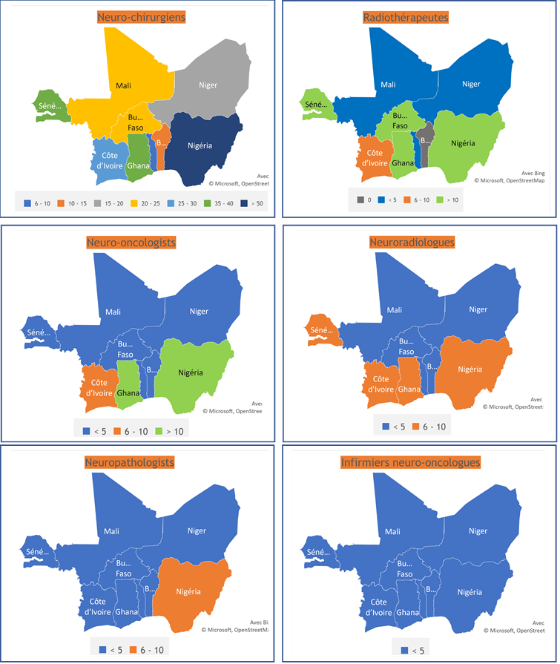

**Figure 1:**Spectral distribution of specialist staff by discipline in the ECOWAS region

1. **Distribution of specialists in the existence of a multidisciplinary consultation framework in neuro-oncology in the ECOWAS region**

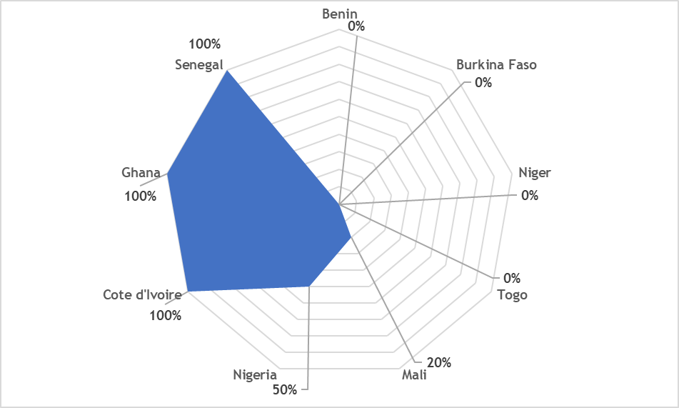

**Figure 2:**Distribution of specialists in the existence of a multidisciplinary consultation framework in neuro-oncology in the ECOWAS region

1. **Factors associated with the lack of a multidisciplinary consultation framework in neuro-oncology in the ECOWAS region**

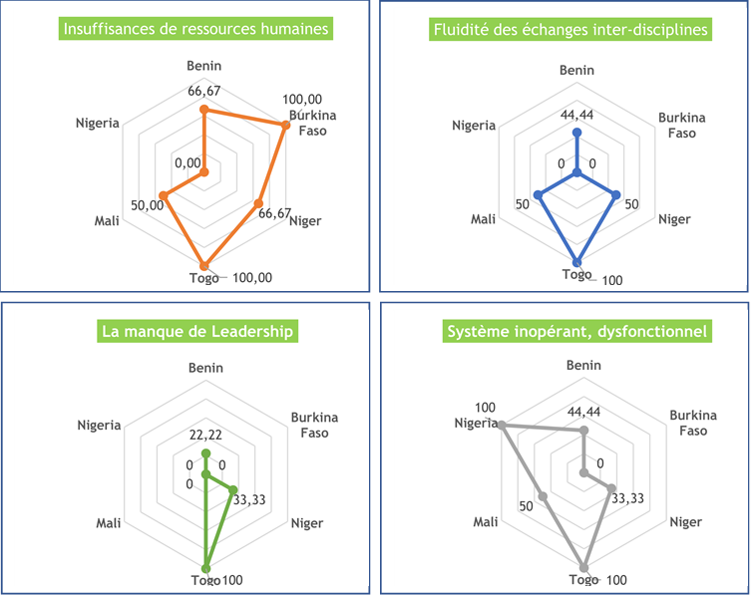

**Figure 3:**Factors associated with the lack of a multidisciplinary consultation framework in neuro-oncology in the ECOWAS region